# The Big Picture

* Published on May 12, 2017

**[](https://www.linkedin.com/in/raydalio)**

## [Ray Dalio](https://www.linkedin.com/in/raydalio)

### Chairman & Chief Investment Officer at Bridgewater Associates, L.P.

**﻿Big picture, the near term looks good and the longer term looks scary.** That is because:

1. The economy is now at or near its best, and we see no major economic risks on the horizon for the next year or two,
2. There are significant long-term problems (e.g., high debt and non-debt obligations, limited abilities by central banks to stimulate, etc.) that are likely to create a squeeze,
3. Social and political conflicts are near their worst for the last number of decades, and
4. Conflicts get worse when economies worsen.

So while we have no near-term economic worries for the economy as a whole, we worry about what these conflicts will become like when the economy has its next downturn.

The next few pages go through our picture of the world as a whole, followed by a look at each of the major economies. We recommend that you read the first part on the world picture and look at the others on individual countries if you’re so inclined.

**Where We Are Within Our Template**

To help clarify, we will repeat our template (see [www.economicprinciples.org](http://www.economicprinciples.org/)) and put where we are within that context.

There are three big forces that drive economies: there’s the normal business/short-term debt cycle that typically takes 5 to 10 years, there’s the long-term debt cycle, and there’s productivity. There are two levers to control them: monetary policy and fiscal policy. And there are the risk premiums of assets that vary as a function of changes in monetary and fiscal policies to drive the wealth effect.

The major economies right now are in the middle of their short-term debt cycles, and growth rates are about average. In other words, the world economy is in the Goldilocks part of the cycle (i.e., neither too hot nor too cold). As a result, volatility is low now, as it typically is during such times. Regarding this cycle, we don’t see any classic storm clouds on the horizon. Unlike in 2007/08, we don’t now see big unsustainable debt flows or a lot of debts maturing that can’t be serviced, and we don’t see monetary policy as a threat. At most, there will be a little touching the brakes by the Fed to slow moderate growth a smidgen. So all looks good for the next year or two, barring some geopolitical shock.

At the same time, the longer-term picture is concerning because we have a lot of debt and a lot of non-debt obligations (pensions, healthcare entitlements, social security, etc.) coming due, which will increasingly create a “squeeze”; this squeeze will come gradually, not as a shock, and will hurt those who are now most in distress the hardest.

Central banks’ powers to rectify these problems are more limited than normal, which adds to the downside risks. Central banks’ powers to ease are less than normal because they have limited abilities to lower interest rates from where they are and because increased QE would be less effective than normal with risk premiums where they are. Similarly, effective fiscal policy help is more elusive because of political fragmentation.

**So we fear that whatever the magnitude of the downturn that eventually comes, whenever it eventually comes, it will likely produce much greater social and political conflict than currently exists.**

**The “World” Picture in Charts**

The following section fleshes out what was previously said by showing where the “world economy” is as a whole. It is followed by a section that shows the same charts for each of the major economies. These charts go back to both 1970 and 1920 in order to provide you with ample perspective.

**1) Short-Term Debt/Economic Conditions Are Good**

As shown below, both the amount of slack in the world economy and the rate of growth in the world economy are as close as they get to normal levels. **In other words, overall, the global economy is at equilibrium.**

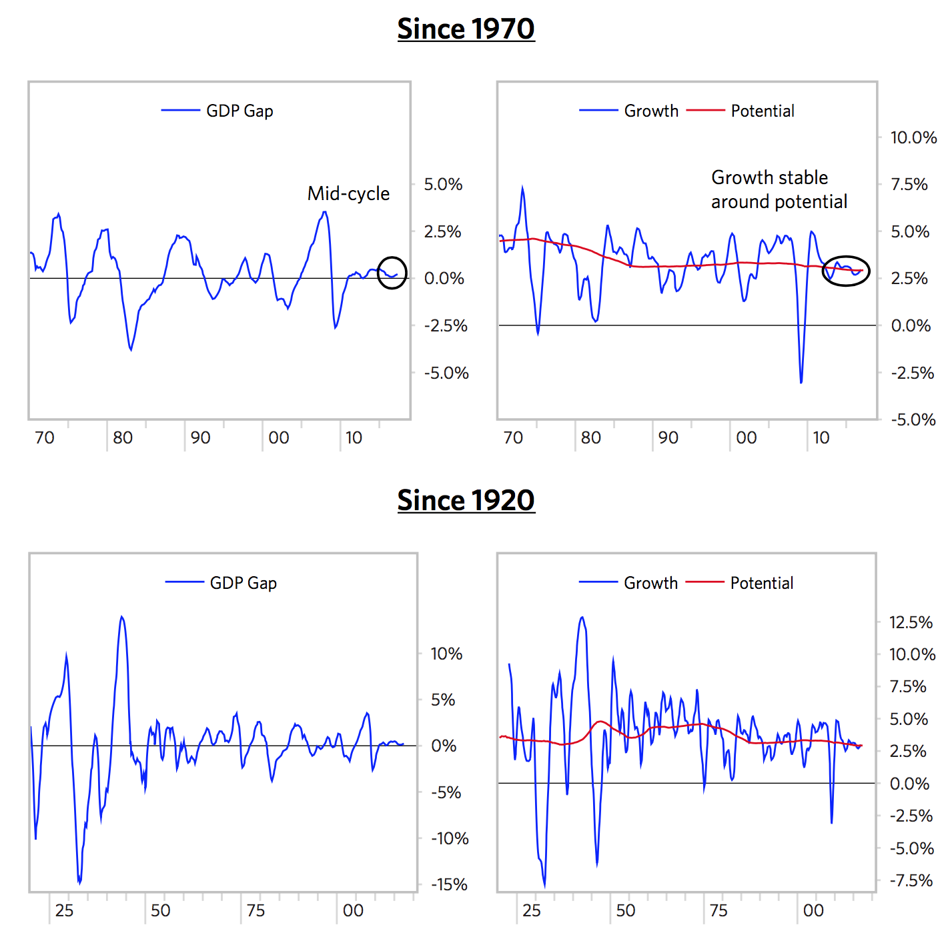

**2) Assets Are Pricing In About Average Risk Premiums (Returns above Cash), Though They Will Provide Low Total Returns**

Liquidity is abundant. Real and nominal interest rates are low—as they should be given where we are in the long-term debt cycle. At the same time, risk premiums of assets (i.e., their expected returns above cash) are normal, and there are no debt crises on the horizon.

Since all investments compete with each other, all investment assets’ projected real and nominal returns are low, though not unusually low in relation to cash rates. The charts below show our expectations for asset returns (of a global 50/50 stock/bond portfolio). While those returns are low, they’re not low relative to cash rates.

Relative to cash, the ‘risk premiums’ of assets are about normal compared to the long-term average. So, both the short-term/business cycle and the pricing of assets look about right to us.

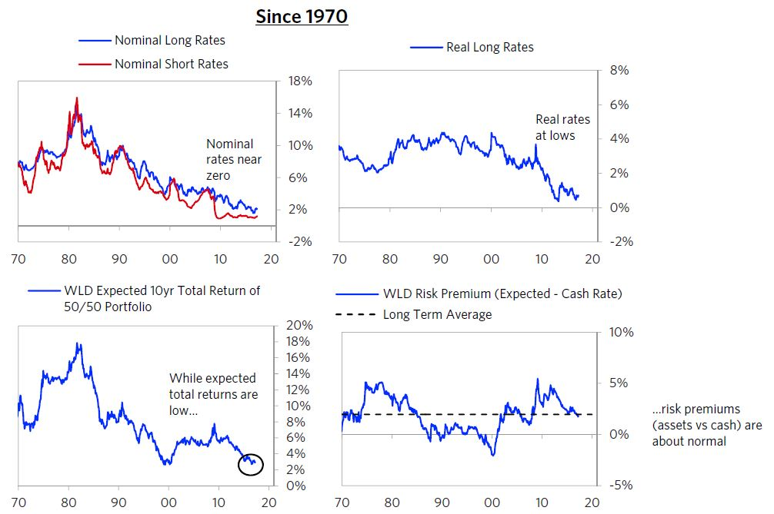

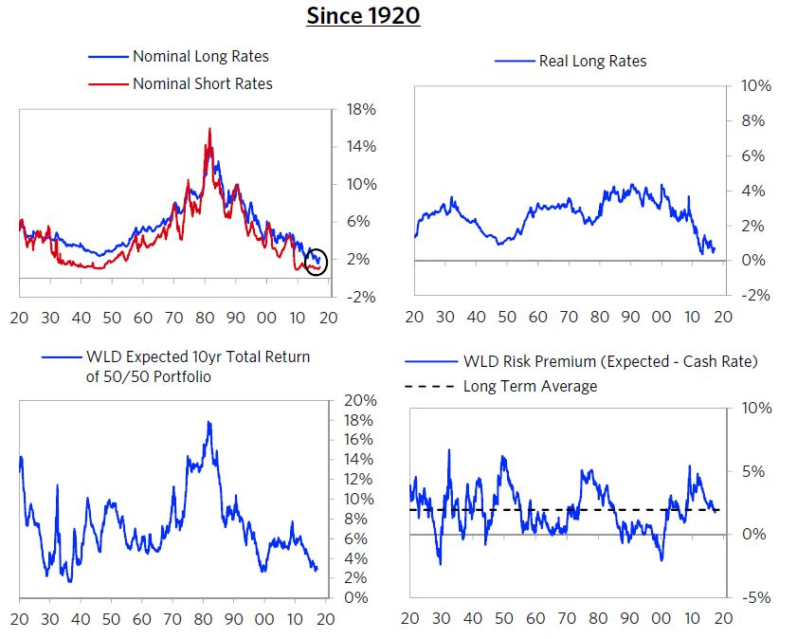

**3) The Longer Term Debt Cycle Is a Negative**

Debt and non-debt obligations (e.g., for pensions, healthcare entitlements, social security, etc.) are high.

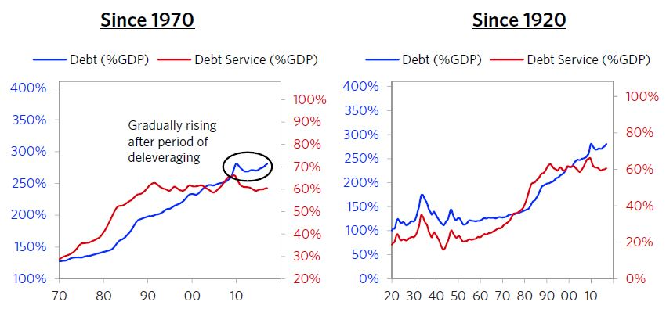

**4) Productivity Growth Is Low**

Over the long term, what raises living standards is productivity—the amount that is produced per person—which increases from coming up with new ideas and implementing ways of producing efficiently. Productivity evolves slowly, so it doesn’t drive big economic and market moves, though it adds up to what matters most over the long run. Here are charts of productivity as measured by real GDP per capita.

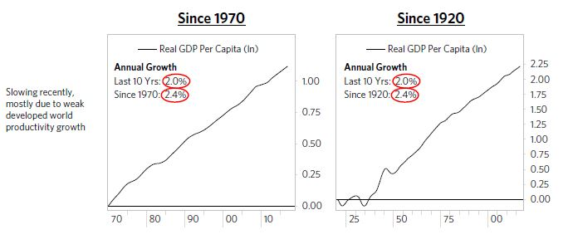

**5) Economic, Political, and Social Fragmentation Is Bad and Worsening**

There are big differences in wealth and opportunity that have led to social and political tensions that are significantly greater than normal, and are increasing. Since such tensions are normally correlated with overall economic conditions, it is unusual for social and political tensions to be so bad when overall economic and market conditions are so good. So we can’t help but worry what the social and political fragmentation will be like in the next downturn, which, by the way, we see no reason to happen over the next year or two.

Below we show a gauge maintained by the Federal Reserve Bank of Philadelphia that attempts to measure political conflict in the US by looking at the share of newspaper articles that cover political conflict from a few continuously running newspapers (NYT, WSJ, etc.). By this measure, conflict is now at highs and rising. The idea of conflicts getting even worse in a downturn is scary.

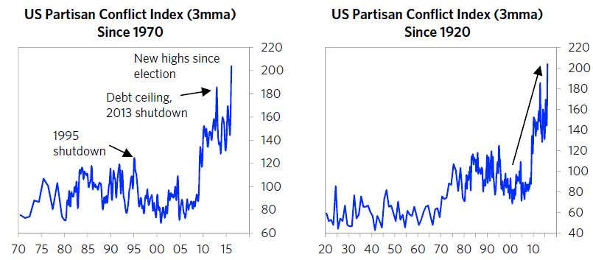

Downturns always come. When the next downturn comes, it’s probably going to be bad.

Below, we go through different countries/regions, one by one.

### ****Looking at the Individual Economic Blocs****

**United States**

As shown below, the US is around equilibrium in the mid-to-late stages of the short-term debt cycle (i.e., the “in between” years), and growth remains moderately strong. Secularly, the US is at the end of the long-term debt cycle. Debt levels are high and have leveled off after a period of deleveraging. The Fed has started to tighten gradually, but interest rates remain low, so the Fed has limited room to ease in the event of a downturn. And as we’ve covered in prior Observations(so won’t go into here), the US is in a period of exceptional political uncertainty as the new administration’s policies continue to take shape.

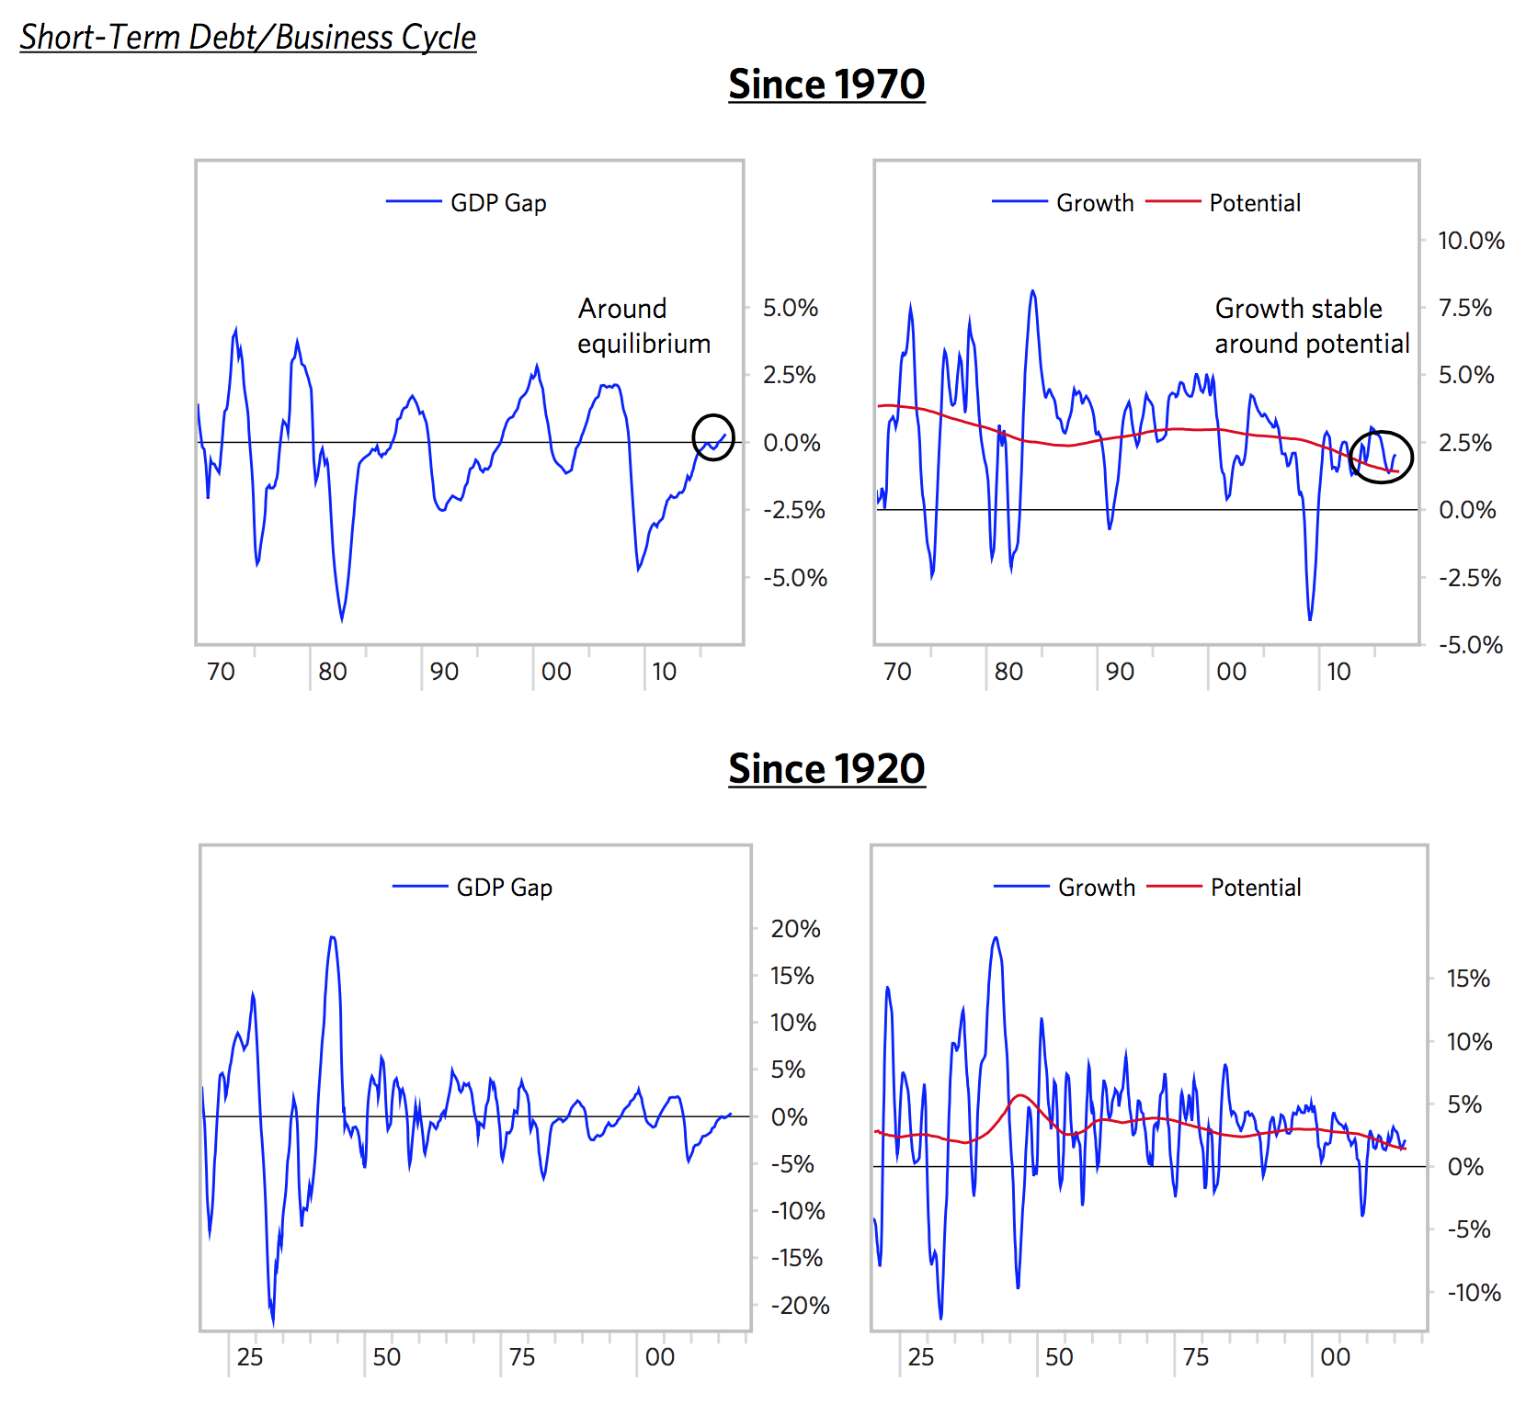

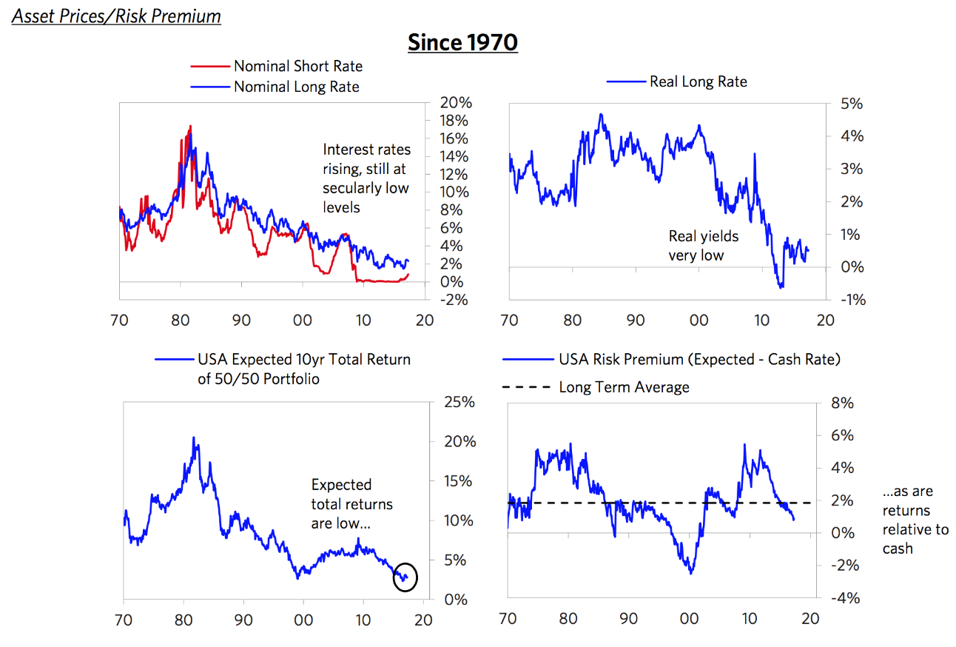

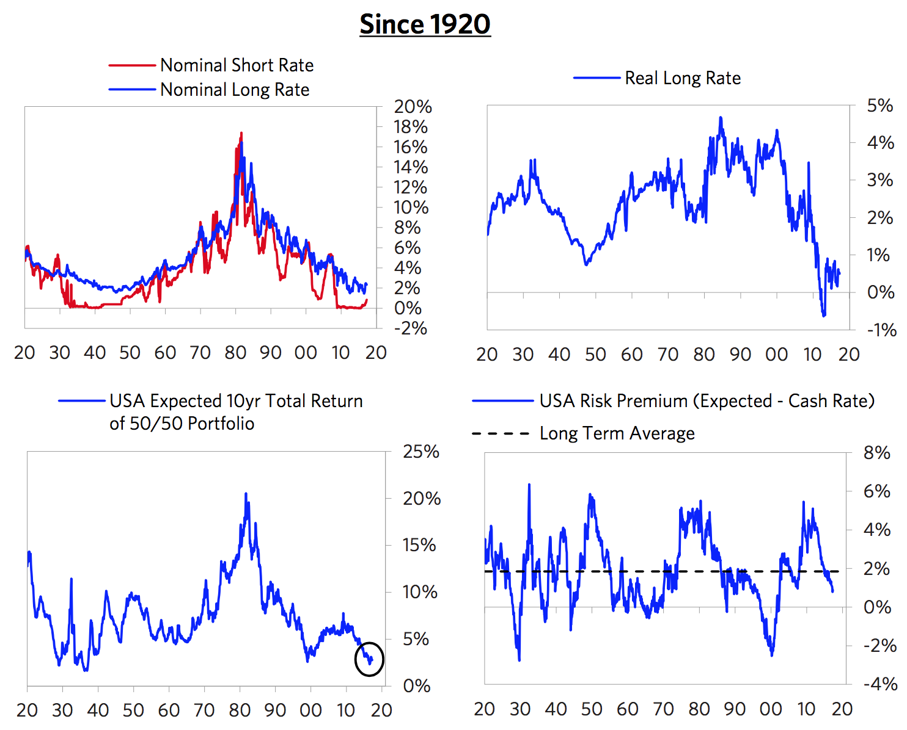

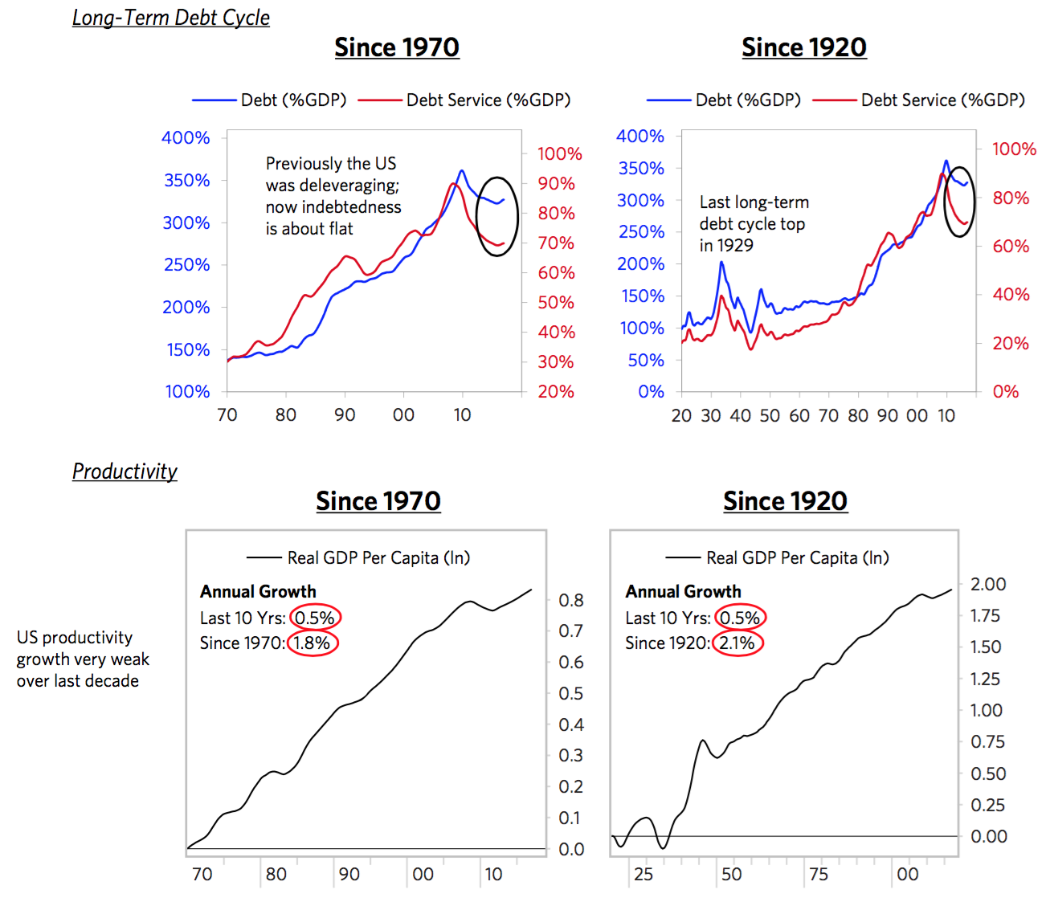

**Eurozone**

While there are two Europes within Europe, we will talk about the Eurozone as a whole (as we have covered the different parts in other Observations). The region is around cyclical equilibrium, but this masks significant divergences between depressed periphery countries and Germany, where the economy is running hot. In response to ECB stimulation, growth has picked up a bit, but inflation is still very weak and below the ECB target. Secularly, Europe is also at the end of the long-term debt cycle. Debt levels are high and haven’t fallen much. Nominal interest rates on both the short and the long end are around zero and are priced to stay low for years. We won’t go into detail here, but Europe also faces one of the most challenging political backdrops due to the growing support for populism.

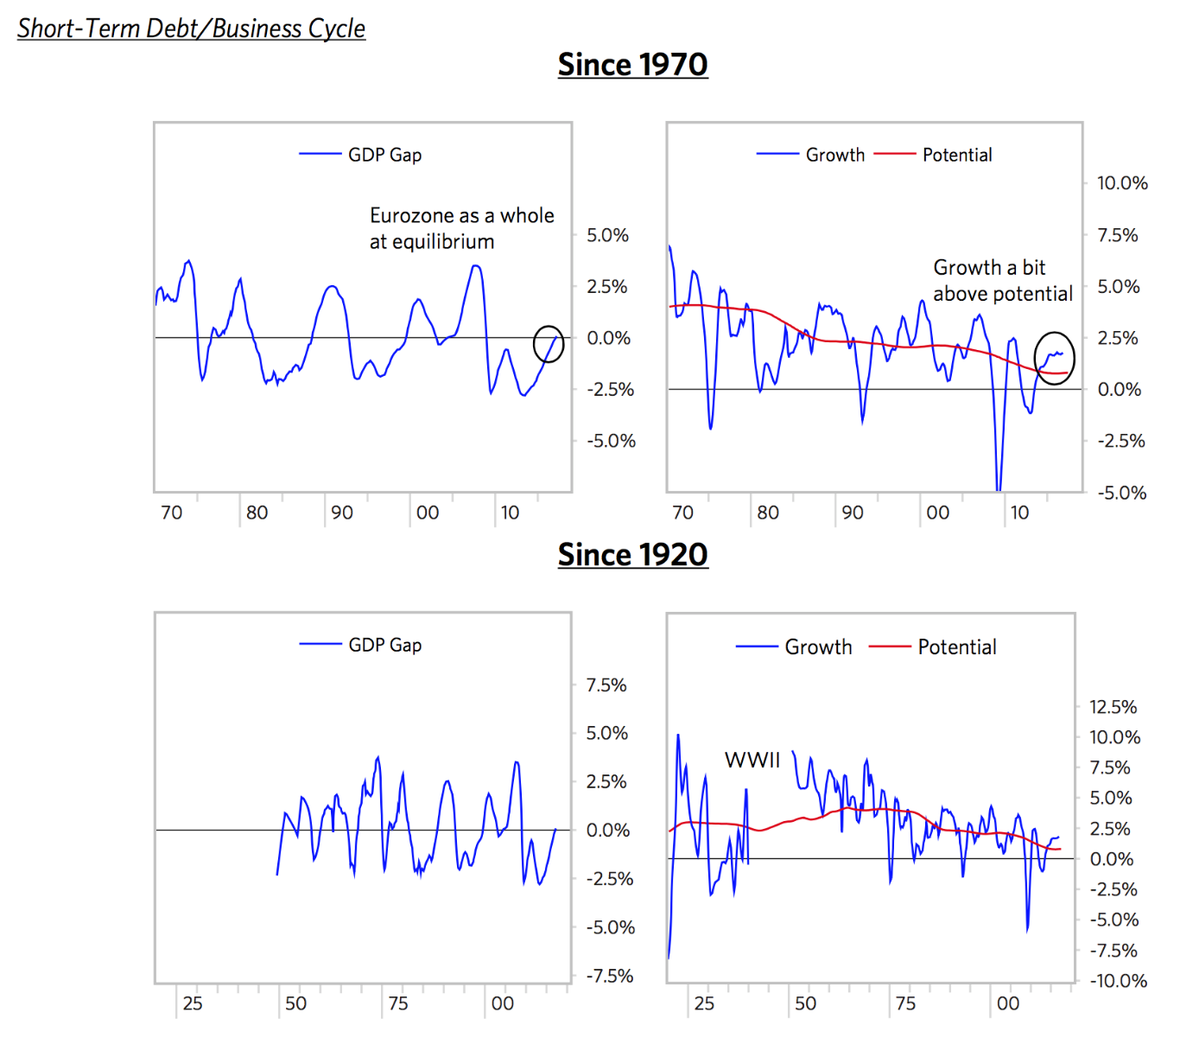

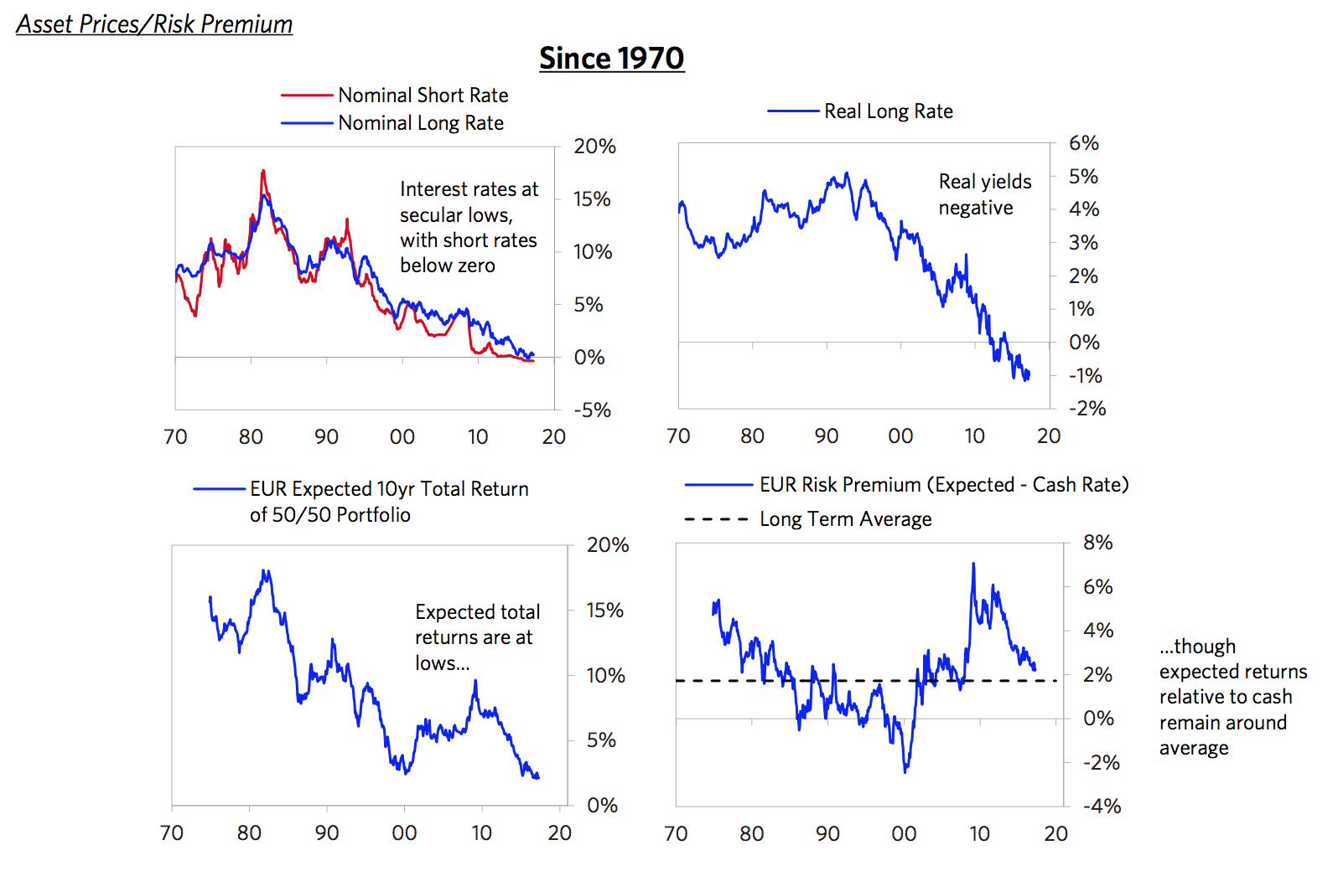

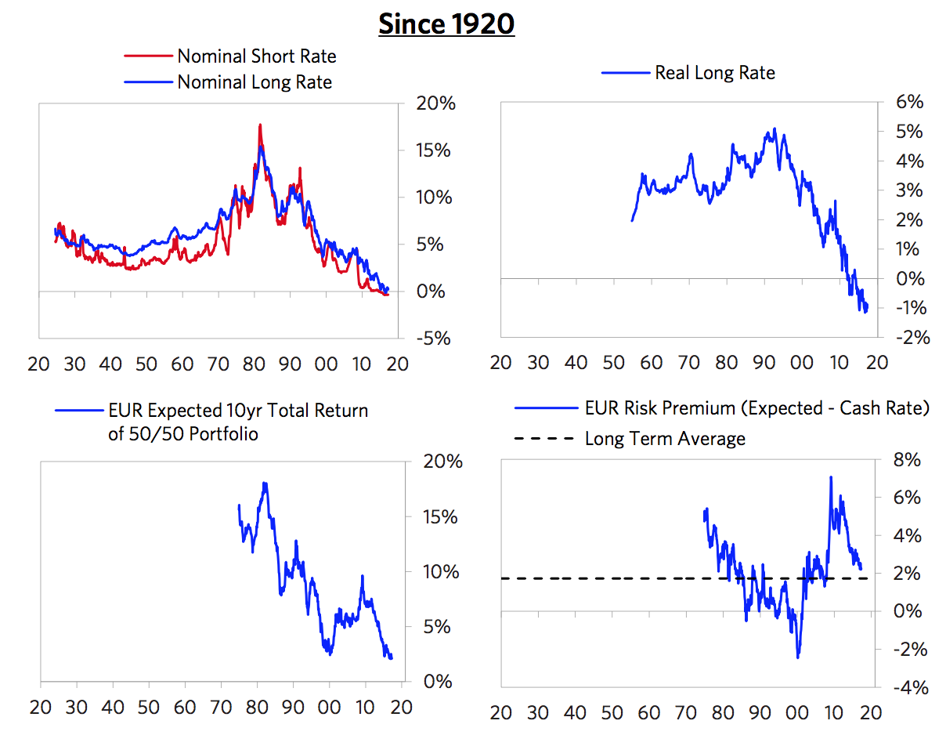

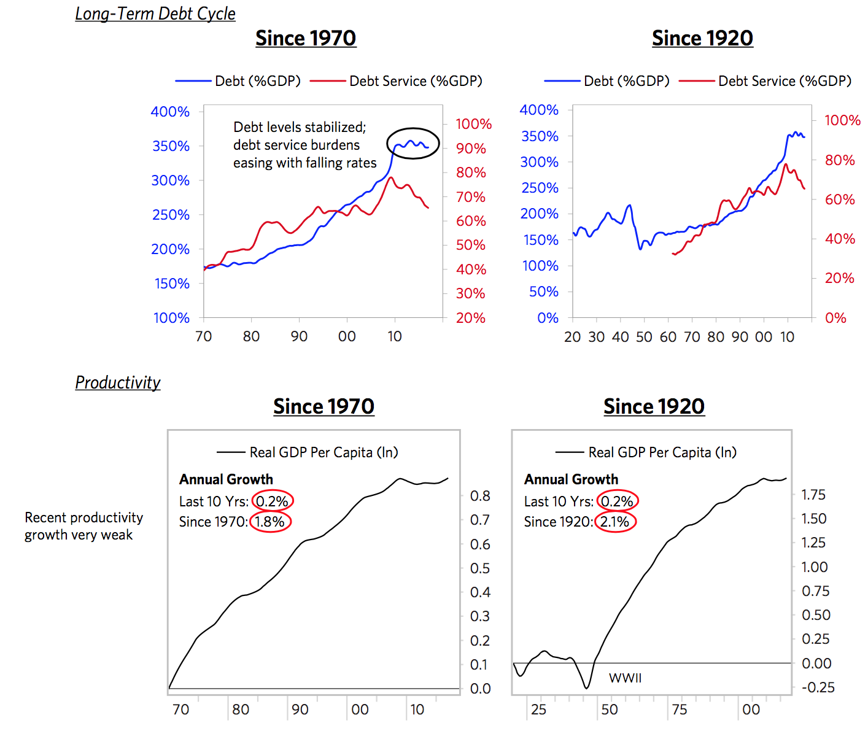

**Japan**

In Japan, policy makers are trying to reverse decades of ugly deflationary deleveraging and shift to a beautiful deleveraging. As shown below, over the last several years, the BoJ’s policies have produced a cyclical upswing and eased deflation. Japan is now around its cyclical equilibrium, growth rates have picked up a bit, and inflation is still very low but the economy is no longer in deflation. Secularly, Japan is at the end of the long-term debt cycle, with the highest debt levels in the developed world (which the BoJ is monetizing at the fastest rate). Debt is still rising, driven by government borrowing. Interest rates have been around zero for two decades and are priced to stay there.

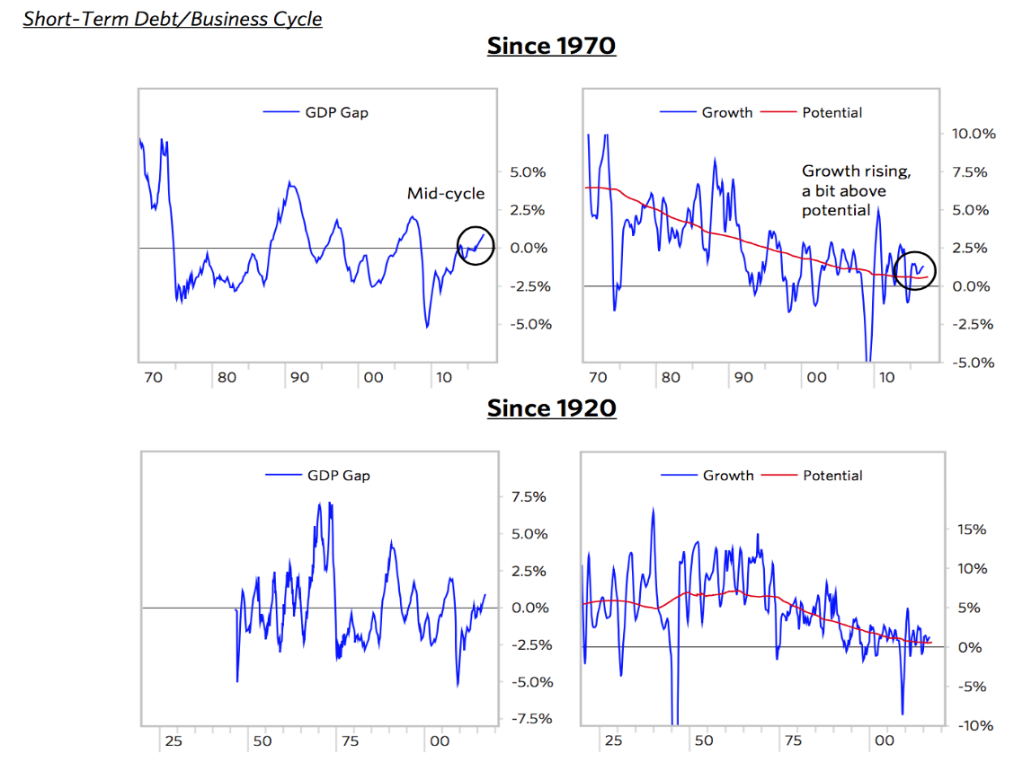

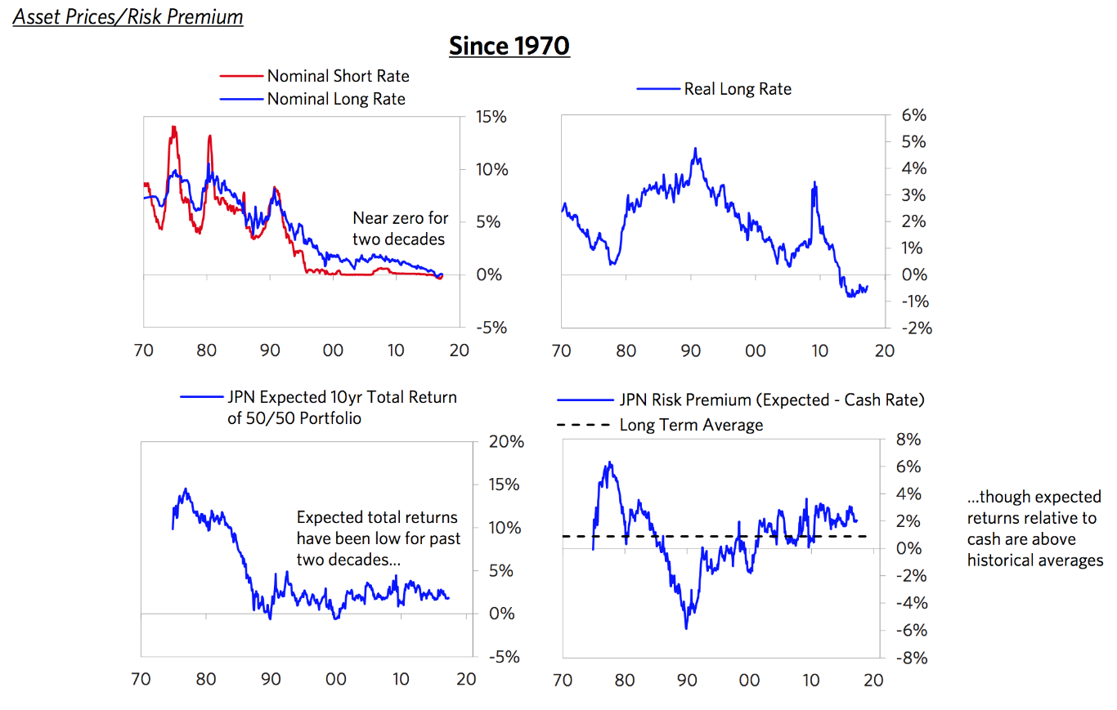

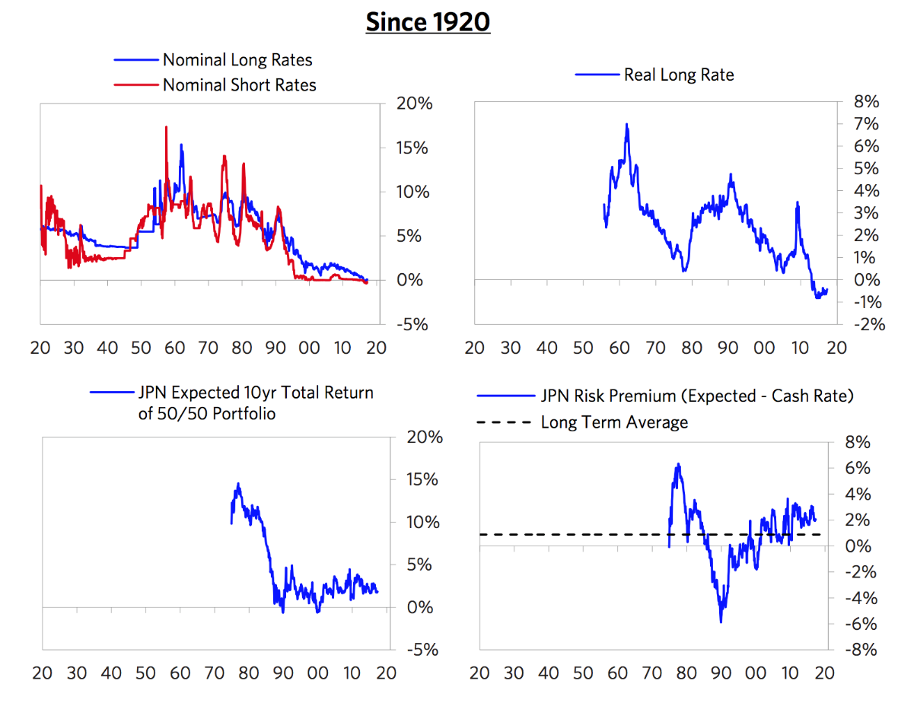

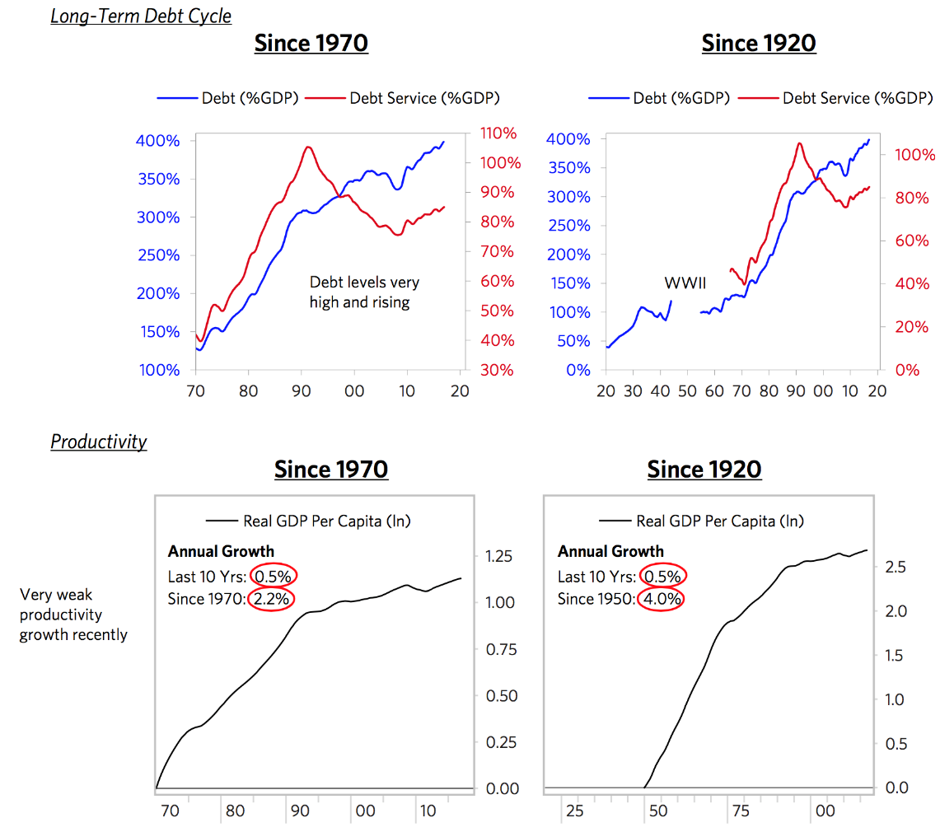

**China**

We’ve previously described that China faces four big economic challenges (debt restructuring; economic restructuring; capital markets restructuring; and the balance of payments/currency issue) that are being well managed. We won’t go into these challenges here other than to emphasize that they are an important backdrop for the perspective shown below. Cyclically, overall levels of activity in China are neither too high nor too low; growth has accelerated and is now strong; and while inflation has picked up some, it remains modest. Debt levels are high and growing rapidly. Interest rates remain relatively low, though these have risen some recently. Under the hood, these aggregate conditions are the net of “two economies” that look very different: a slowing, heavily indebted “old economy” with pockets of excess capacity, and a steadily expanding “new economy” driven by higher-end industries and household consumption.

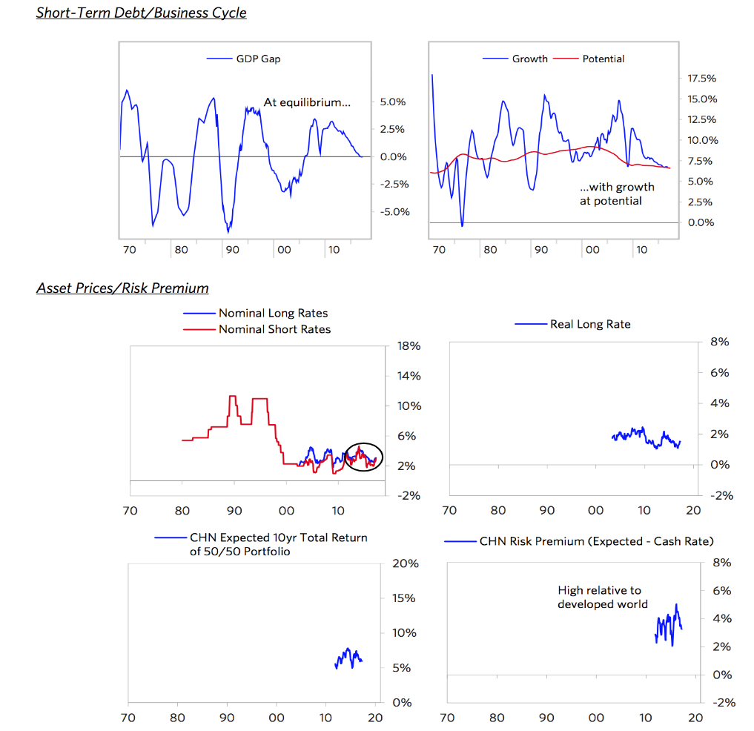

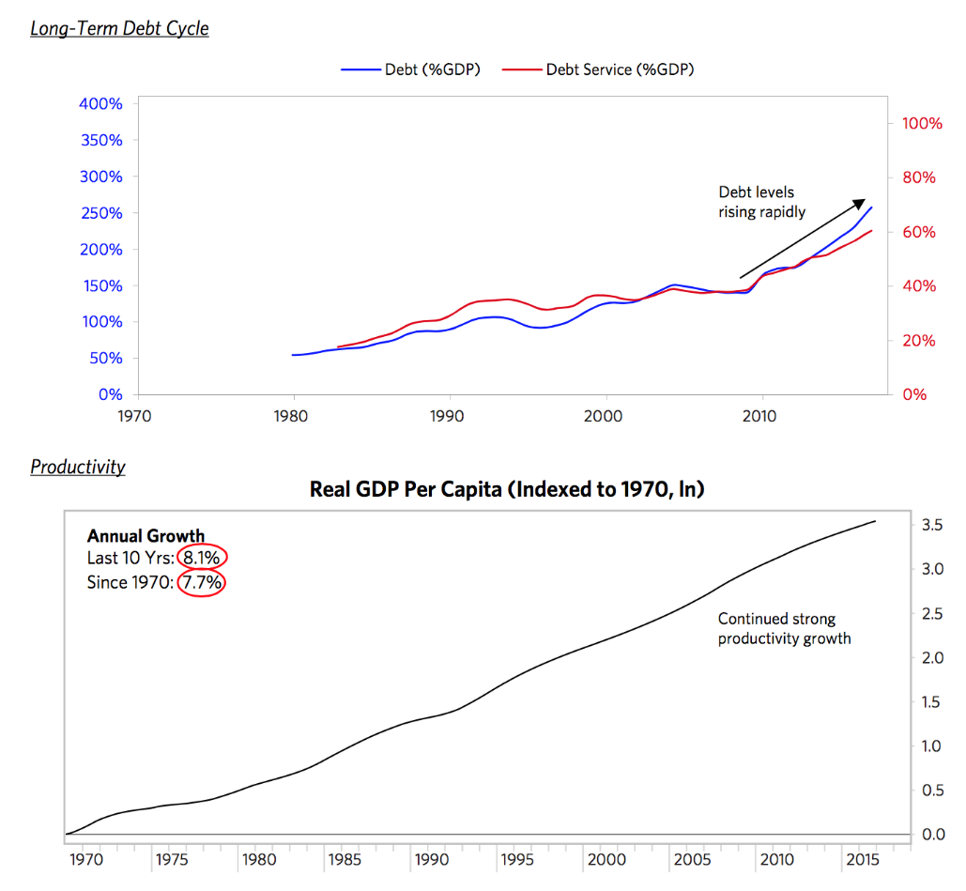

**Emerging Markets ex-China**

Obviously, this category aggregates many countries with many different sets of circumstances, which we won’t get into here. Overall, cyclical conditions in EM ex-China are a bit weaker than in the developed world, reflecting, that several of the largest countries (e.g., Brazil, Russia) are now recovering from balance of payments adjustments. But the longer-term picture is comparatively stronger. These EM countries haven’t yet seen much of a productivity slowdown akin to what the developed world has seen, and debt burdens remain low.

